NEED LAB WORK? SAVE MONEY!

You have a choice when it comes to where your lab work is collected and tested. To save money, pick an independent laboratory instead of a hospital lab. Here’s how:
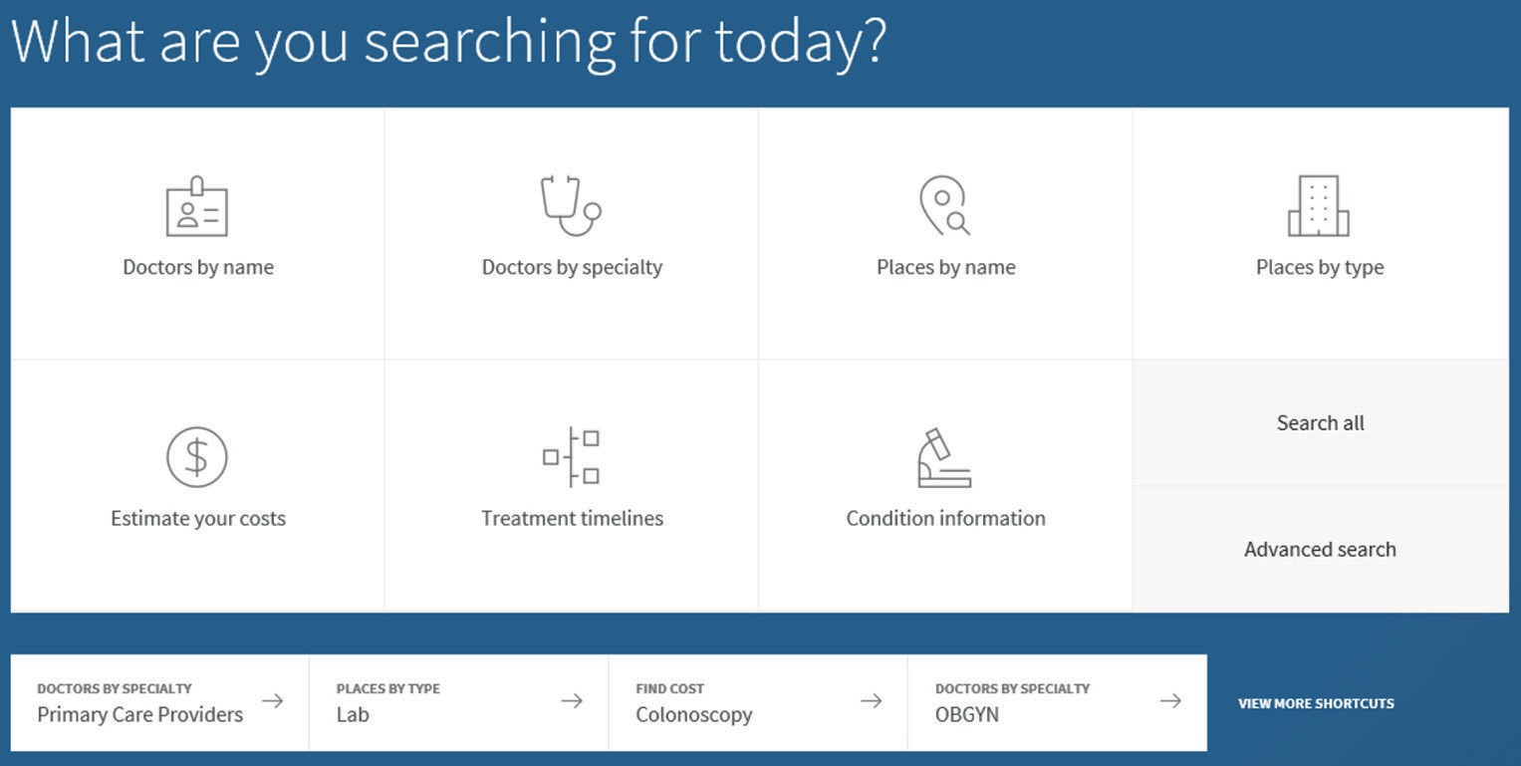

Step
1
Log in to your secure account at CapitalBlueCross.com and choose Find > Doctors
Step
2
Select the Places by Type - Lab shortcut
Step
3
If needed, refine results by selecting Specialty - Independent Laboratory

Quest Diagnostics

Independent Laboratory
Compare 123 Main St.
Anytown, PA 17110
3.7 miles Get directions (717) 555-1234

If you need lab work, location is important. Before going, check with the lab to be sure they participate in the same BlueCross BlueShield plan as the ordering provider, or you may pay more.
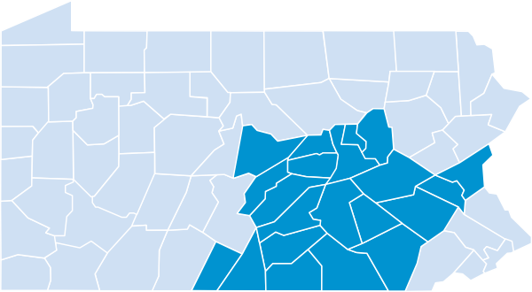
If the provider requesting the lab test is located:

Within our 21-county service area: Stay in-network by using an independent lab that is also located in our 21-county area.

Outside our 21-county service area: Stay in-network by using a network laboratory in the same service area as your ordering provider.

21-County Service Area: Adams, Berks, Centre, Columbia, Cumberland, Dauphin, Franklin, Fulton, Juniata, Lancaster, Lebanon, Lehigh, Mifflin, Montour, Northampton, Northumberland, Perry, Schuylkill, Snyder, Union, York
Using these guidelines, you and your doctor’s office can work together to find an independent laboratory that can help you save money.



SAVE MONEY. PICK INDEPENDENT LABS.


Your actual out-of-pocket costs for lab tests depend on your plan. Refer to the Certificate of Coverage (benefit booklet) for any copayment, deductible, or coinsurance you may owe for lab services. Regardless of your plan, independent labs bill less than hospital labs. Often much less, as illustrated below:
Common lab tests | Member rate for a hospital laboratory averages | Member rate for an independent lab averages only
Comprehensive Metabolic Panel Evaluates overall body function and the health of certain organs. | $74 | $11
Lipid Panel  Measures levels of cholesterol and other fats. | $77 | $13
Thyroid Stimulating Hormone Test Measures the level of free TSH, a hormone that indicates thyroid health. | $101 | $16
Urinalysis  Checks urine for signs of disease. | $26 | $3
Hemoglobin A1c  Blood test used to diagnose and help manage diabetes. | $62 | $9

SAVE MONEY. HERE’S HOW:
Blood drawn at your doctor’s office?
Ask them to use an independent lab for testing.
Given a prescription for future lab work?
Pick an independent lab to draw your blood.



CapitalBlueCross.com

Source: Capital BlueCross data, December 2019
Cost comparisons are built from a historical range of amounts paid to providers. This is not a recommendation or endorsement of any particular healthcare provider or its services and should not be construed as medical advice. Capital BlueCross does not guarantee that services will be available or will be any particular quality or cost.
Healthcare benefit programs issued or administered by Capital BlueCross and/or its subsidiaries, Capital Advantage Insurance Company®, Capital Advantage Assurance Company®, and Keystone Health Plan® Central. Independent licensees of the BlueCross BlueShield Association. Communications issued by Capital BlueCross in its capacity as administrator of programs and provider relations for all companies.
C-712 (05/05/20)

